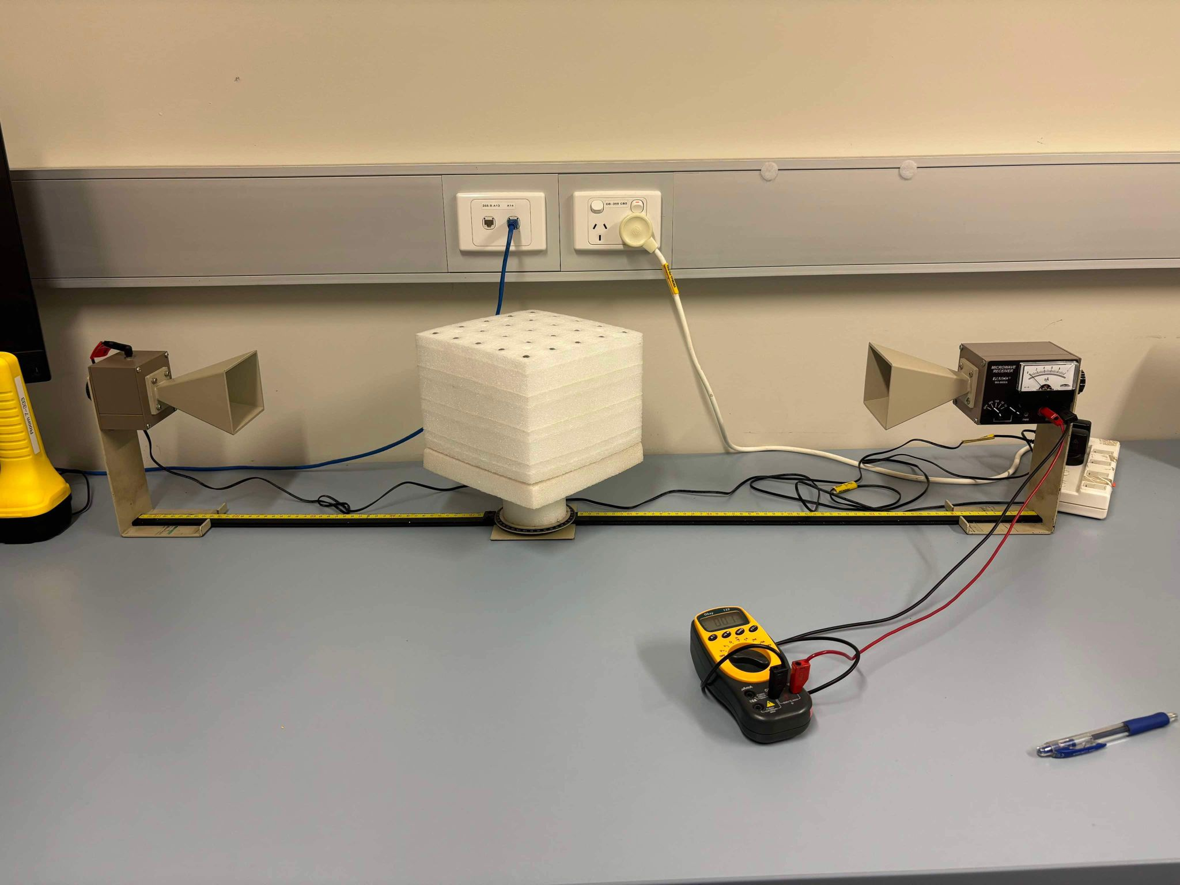

5

4

34

2

1

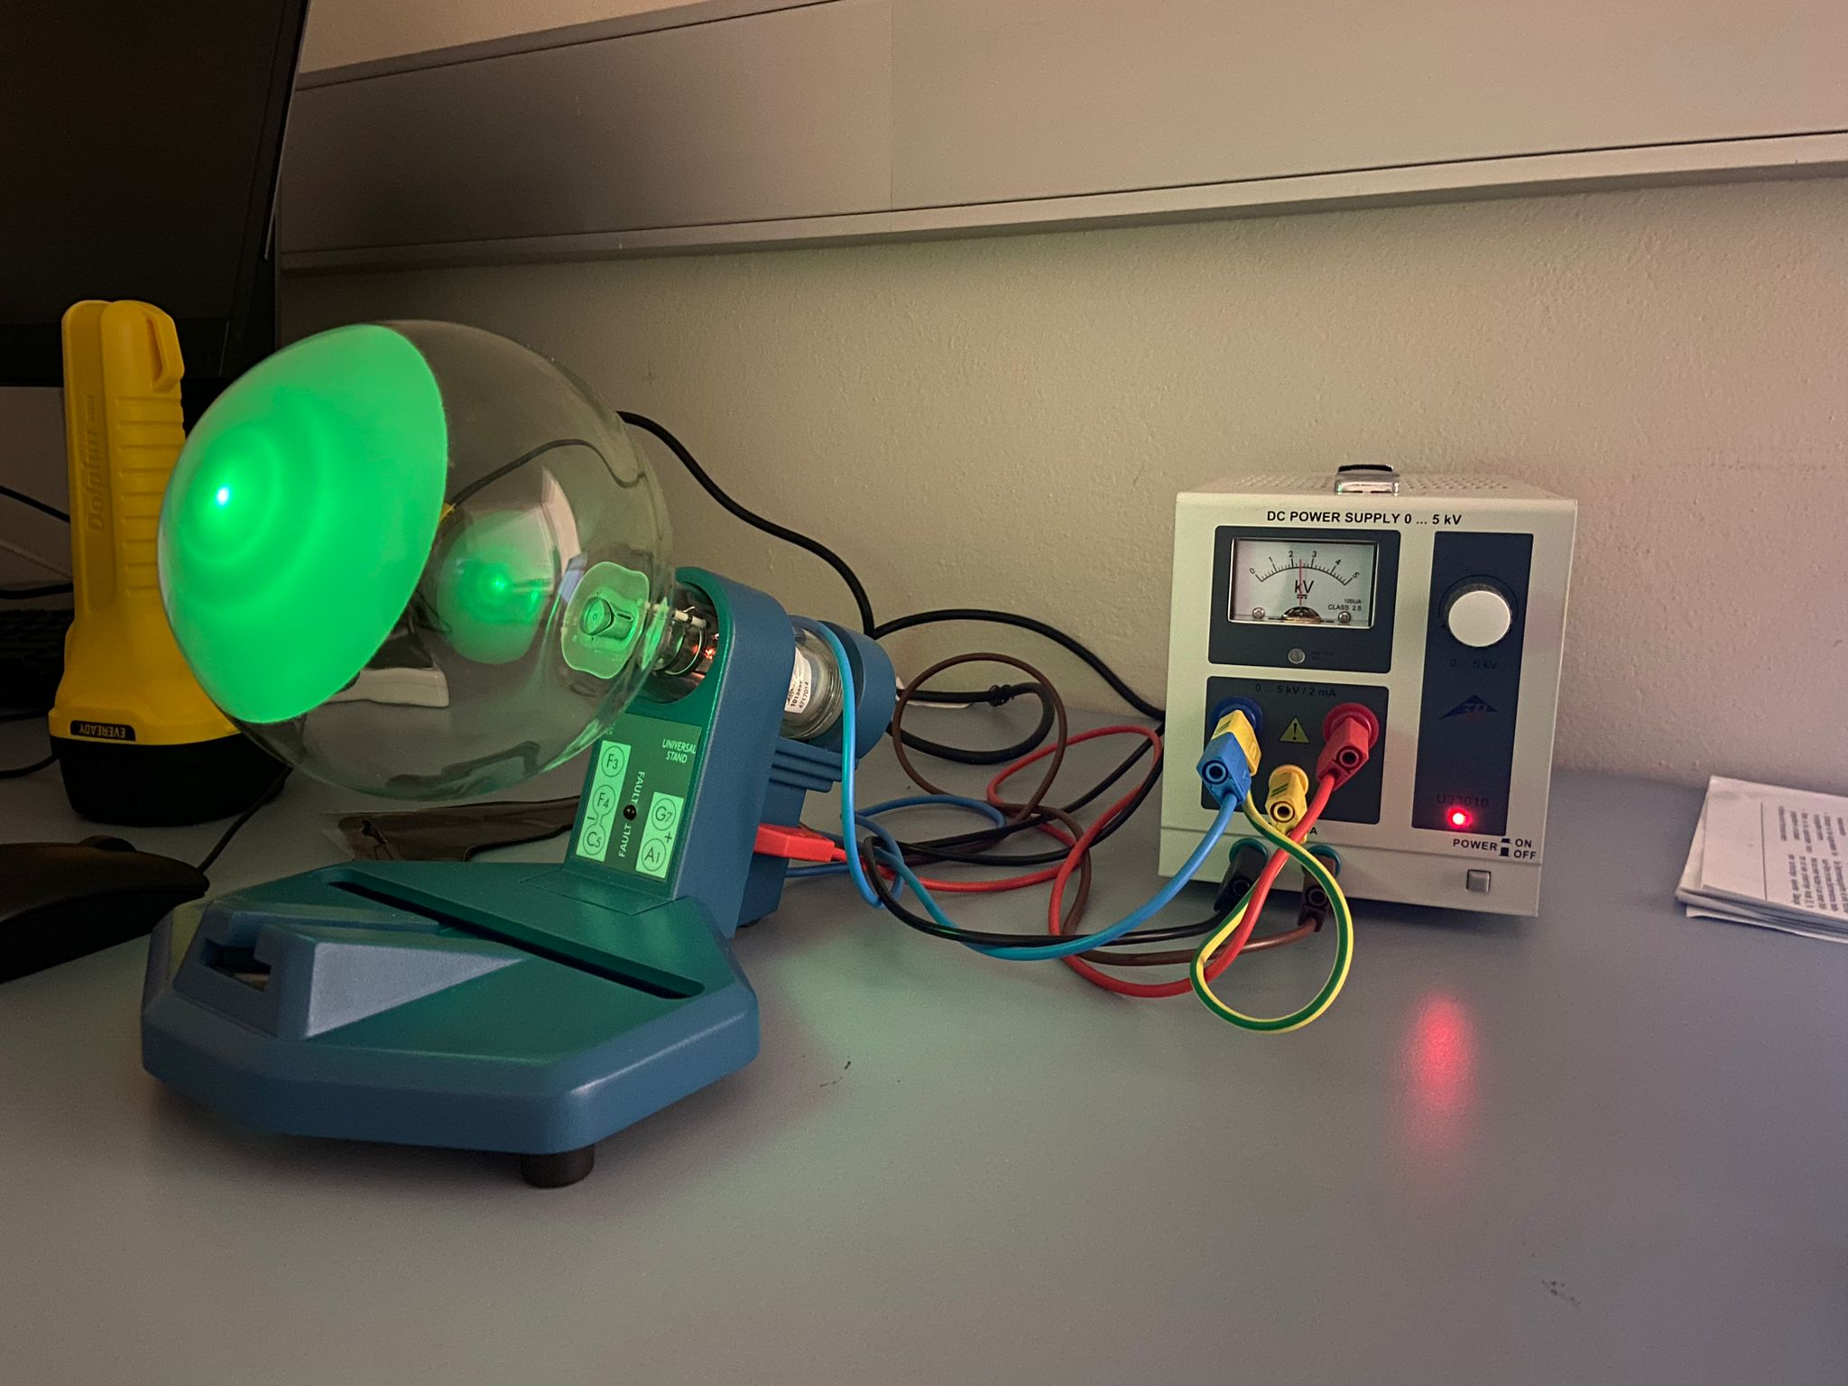

3

2

1

4

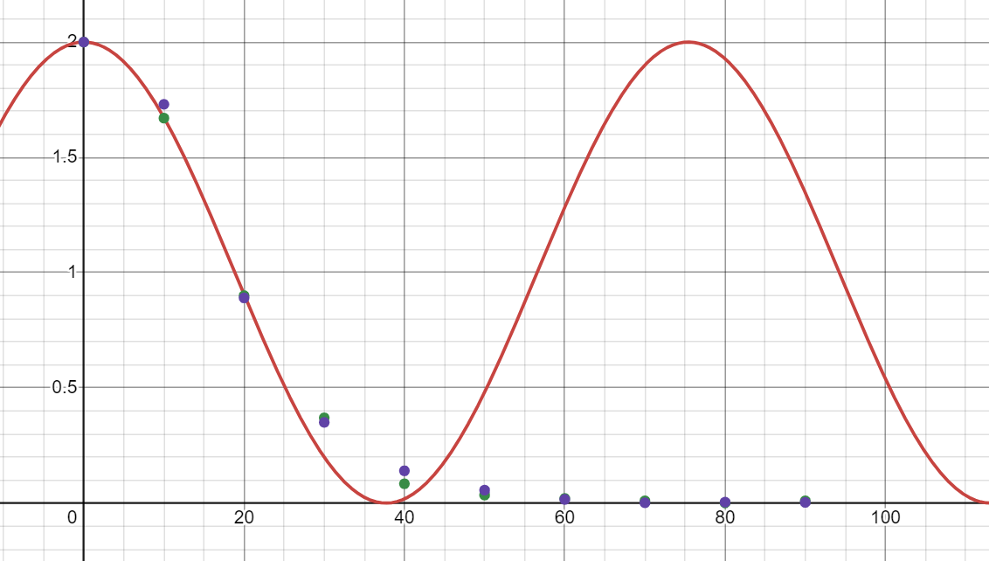

θ

V